Device: cuda
GPU: NVIDIA A100-SXM4-40GB
VRAM: 42.4 GB

PBT-V v5.5a Adapter:
Total params: 7,595,610
Module W params: 4,743,180 (Probabilistic)
Module M params: 39 (LSTM)
Beta init: [1.0, 1.0, 1.0] (equal)

==========================================================================================
Creating STL-10 Real Photo Sequences
96×96 RGB — 3× resolution of CIFAR-10
==========================================================================================
Downloading STL-10...
100%|██████████| 2.64G/2.64G [02:53<00:00, 15.2MB/s]
Total images: 13000
airplane (class 0): 1300
bird (class 1): 1300
car (class 2): 1300
cat (class 3): 1300
deer (class 4): 1300
dog (class 5): 1300
horse (class 6): 1300
monkey (class 7): 1300
ship (class 8): 1300
truck (class 9): 1300

Total: 1250 seq × 8 frames = 10000 frames
Train: 875 | Val: 187 | Test: 188

By type:
context_animal_cat : 100
context_vehicle_cat : 100
drift_safe : 150
gradual_drift : 200
normal_animal : 200
normal_vehicle : 300
sudden_anomaly : 200
preprocessor_config.json: 100%
436/436 [00:00<00:00, 51.2kB/s]
The image processor of type `BitImageProcessor` is now loaded as a fast processor by default, even if the model checkpoint was saved with a slow processor. This is a breaking change and may produce slightly different outputs. To continue using the slow processor, instantiate this class with `use_fast=False`.
Building tensor sequences...
Train...
Train done: 875 sequences
Val...
Val done: 187 sequences
Test...
Test done: 188 sequences

Image shape: torch.Size([8, 3, 224, 224])
Dataset ready!

==========================================================================================
Pre-computing Hidden States (DINOv2-Base on STL-10)
==========================================================================================
config.json: 100%
548/548 [00:00<00:00, 70.7kB/s]
model.safetensors: 100%
346M/346M [00:01<00:00, 505MB/s]
Loading weights: 100%
223/223 [00:00<00:00, 1033.61it/s, Materializing param=layernorm.weight]
DINOv2-Base loaded: 87M params

TRAIN...
Train 100/875 (7s)
Train 200/875 (14s)
Train 300/875 (21s)
Train 400/875 (28s)
Train 500/875 (35s)
Train 600/875 (41s)
Train 700/875 (48s)
Train 800/875 (55s)
Train done: 875 seq in 60s
VAL...
Val 100/187 (7s)
Val done: 187 seq in 13s
TEST...
Test 100/188 (7s)
Test done: 188 seq in 13s

Hidden state shape: torch.Size([8, 12, 768])
Expected: [8, 12, 768]
DINOv2 unloaded, GPU memory freed

==========================================================================================
Training PBT-V v5.5a (A-E-V-M_LSTM-W_Probabilistic Loop)
KEY: Module W now predicts mu + log_var (Probabilistic)
==========================================================================================
Epoch 0 | Loss 1.321 | W_NLL -2.508 | Train 94.3% | Val 95.9% | β [0.90,0.92,0.89] | σ² 0.2851 | Π_max 1.70 ★ BEST
Epoch 1 | Loss 1.095 | W_NLL -3.167 | Train 95.6% | Val 96.2% | β [0.90,0.92,0.89] | σ² 0.2411 | Π_max 1.92 ★ BEST
Epoch 5 | Loss 0.946 | W_NLL -3.276 | Train 96.7% | Val 96.1% | β [1.24,1.20,1.10] | σ² 0.2335 | Π_max 4.83
Epoch 6 | Loss 0.737 | W_NLL -3.288 | Train 96.9% | Val 96.7% | β [1.24,1.17,1.09] | σ² 0.2376 | Π_max 4.58 ★ BEST
Epoch 7 | Loss 0.704 | W_NLL -3.294 | Train 97.2% | Val 97.1% | β [1.31,1.19,1.20] | σ² 0.2397 | Π_max 4.45 ★ BEST
Epoch 10 | Loss 0.228 | W_NLL -3.327 | Train 99.3% | Val 97.9% | β [1.44,1.18,1.51] | σ² 0.2320 | Π_max 4.77 ★ BEST
Epoch 11 | Loss 0.252 | W_NLL -3.345 | Train 99.5% | Val 98.7% | β [1.43,1.15,1.46] | σ² 0.2244 | Π_max 4.48 ★ BEST
Epoch 13 | Loss 0.057 | W_NLL -3.368 | Train 99.9% | Val 98.9% | β [1.38,1.12,1.34] | σ² 0.2191 | Π_max 4.35 ★ BEST
Epoch 14 | Loss 0.095 | W_NLL -3.376 | Train 99.8% | Val 99.1% | β [1.41,1.14,1.33] | σ² 0.2149 | Π_max 4.57 ★ BEST
Epoch 15 | Loss 0.065 | W_NLL -3.388 | Train 99.8% | Val 99.3% | β [1.41,1.16,1.29] | σ² 0.2137 | Π_max 5.14 ★ BEST
Epoch 16 | Loss 0.094 | W_NLL -3.395 | Train 99.9% | Val 99.5% | β [1.43,1.18,1.27] | σ² 0.2117 | Π_max 5.08 ★ BEST
Epoch 17 | Loss 0.063 | W_NLL -3.403 | Train 99.9% | Val 99.6% | β [1.44,1.19,1.28] | σ² 0.2088 | Π_max 5.06 ★ BEST
Epoch 20 | Loss 0.076 | W_NLL -3.426 | Train 99.8% | Val 99.3% | β [1.43,1.18,1.18] | σ² 0.2043 | Π_max 5.93
Epoch 25 | Loss 0.019 | W_NLL -3.465 | Train 99.9% | Val 98.9% | β [1.36,1.09,1.19] | σ² 0.1953 | Π_max 6.81
Epoch 30 | Loss 0.019 | W_NLL -3.497 | Train 100.0% | Val 99.0% | β [1.27,1.00,1.17] | σ² 0.1897 | Π_max 7.78
Epoch 35 | Loss 0.000 | W_NLL -3.518 | Train 100.0% | Val 98.8% | β [1.23,0.94,1.17] | σ² 0.1862 | Π_max 8.15

Best val: 99.6%
Training time: 8275s
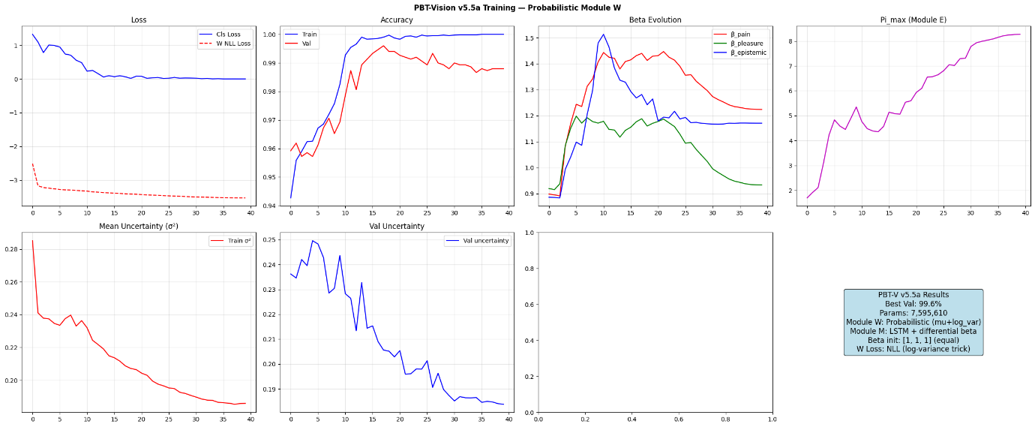
Saved: pbt_vision_v55a.pth

==========================================================================================
Comprehensive Test + Ablation — PBT-V v5.5b
==========================================================================================

Overall: 99.9%

precision recall f1-score support

SAFE 0.9992 0.9992 0.9992 1236
ANOMALY 0.9963 0.9963 0.9963 268

accuracy 0.9987 1504
macro avg 0.9977 0.9977 0.9977 1504
weighted avg 0.9987 0.9987 0.9987 1504

By Type:
context_animal_cat : 99.1% (112 frames)
context_vehicle_cat : 98.6% (72 frames)
drift_safe : 100.0% (248 frames)
gradual_drift : 100.0% (248 frames)
normal_animal : 100.0% (224 frames)
normal_vehicle : 100.0% (384 frames)
sudden_anomaly : 100.0% (216 frames)

Running ablations (Overall Accuracy)...

Configuration Overall
────────────────────────────────────────
Full (A+E+V+M+W) 99.9%
No A (no gating) 98.7%
No W (naive predict) 99.7%
No E (uniform Pi) 99.7%
No M (no memory) 98.2%

==========================================================================================
Context Test: Same Cat, Different Meaning (STL-10 Real Photos)
==========================================================================================

Found: 9 vehicle+cat, 14 animal+cat sequences

Vehicle+Cat (cat among cars/trucks) (should be UNSAFE):
Frame 0: UNSAFE=0.000 R=0.000 gate=0.717 σ²=0.1993 V_acc=[-0.03, 0.01, -0.04]
Frame 1: UNSAFE=0.000 R=-0.310 gate=0.821 σ²=0.1997 V_acc=[-0.06, 0.02, -0.06]
Frame 2: UNSAFE=0.000 R=-0.540 gate=0.829 σ²=0.2020 V_acc=[-0.11, 0.03, -0.15]
Frame 3: UNSAFE=0.000 R=-1.122 gate=0.919 σ²=0.2227 V_acc=[-0.14, 0.03, -0.18]
Frame 4: UNSAFE=1.000 R=-1.364 gate=0.924 σ²=0.1846 V_acc=[-0.27, 0.07, -0.37] ← cat appears
Frame 5: UNSAFE=1.000 R=-2.779 gate=0.998 σ²=0.2227 V_acc=[-0.26, 0.06, -0.32]
Frame 6: UNSAFE=1.000 R=-2.508 gate=0.997 σ²=0.2397 V_acc=[-0.23, 0.05, -0.23]
Frame 7: UNSAFE=1.000 R=-2.006 gate=0.990 σ²=0.2149 V_acc=[-0.22, 0.05, -0.18]

Animal+Cat (cat among deer/dogs/horses) (should be SAFE):
Frame 0: UNSAFE=0.000 R=0.000 gate=0.717 σ²=0.1636 V_acc=[0.01, -0.00, 0.07]
Frame 1: UNSAFE=0.000 R=0.332 gate=0.575 σ²=0.1634 V_acc=[0.01, -0.00, 0.13]
Frame 2: UNSAFE=0.000 R=0.636 gate=0.455 σ²=0.1531 V_acc=[0.02, -0.01, 0.19]
Frame 3: UNSAFE=0.000 R=0.906 gate=0.380 σ²=0.1776 V_acc=[0.02, -0.01, 0.22]
Frame 4: UNSAFE=0.000 R=1.045 gate=0.362 σ²=0.1671 V_acc=[0.03, -0.01, 0.30] ← cat appears
Frame 5: UNSAFE=0.087 R=1.415 gate=0.310 σ²=0.2132 V_acc=[0.02, -0.01, 0.30]
Frame 6: UNSAFE=0.200 R=1.407 gate=0.311 σ²=0.2270 V_acc=[0.02, -0.01, 0.31]
Frame 7: UNSAFE=0.000 R=1.418 gate=0.311 σ²=0.2217 V_acc=[0.01, -0.00, 0.31]

Context Accuracy:
context_vehicle_cat : 98.6% (71/72)
context_animal_cat : 99.1% (111/112)

==========================================================================================
Module Analysis — v5.5b Probabilistic W
==========================================================================================

Module E Precision Pi_l:
Layer 0 (Perception): Pi = 3.0709
Layer 1 (Perception): Pi = 4.4696
Layer 2 (Perception): Pi = 5.0588
Layer 3 (Perception): Pi = 3.6313
Layer 4 (Evaluation): Pi = 3.6254
Layer 5 (Evaluation): Pi = 2.4358
Layer 6 (Evaluation): Pi = 1.9024
Layer 7 (Evaluation): Pi = 2.1146
Layer 8 (Decision ): Pi = 1.8217
Layer 9 (Decision ): Pi = 1.5595
Layer 10 (Decision ): Pi = 0.8489
Layer 11 (Decision ): Pi = 0.5426

Module M v5 — LSTM Gates:
Beta (differential forget bias):
beta_pain = 1.4398
beta_pleasure = 1.1884
beta_epistemic= 1.2815
Effective forget bias (b_f + beta):
pain = 1.8796 → sigmoid = 0.8676
pleasure = 1.3768 → sigmoid = 0.7985
epistemic= 1.5631 → sigmoid = 0.8268

★ Module W — Uncertainty Analysis (sigma^2 per layer)

Layer σ²_safe σ²_unsafe Δσ² MSE_safe MSE_unsafe Δ_MSE
─────────────────────────────────────────────────────────────────────────────────────
Layer 0 (Perception) 0.0000 0.0000 -0.0000 0.0000 0.0000 +0.0000
Layer 1 (Perception) 0.0000 0.0000 +0.0000 0.0001 0.0001 +0.0000
Layer 2 (Perception) 0.0000 0.0000 +0.0000 0.0000 0.0001 +0.0000
Layer 3 (Perception) 0.0002 0.0003 +0.0001 0.0001 0.0002 +0.0000
Layer 4 (Evaluation) 0.0004 0.0005 +0.0001 0.0004 0.0005 +0.0001
Layer 5 (Evaluation) 0.0012 0.0012 +0.0001 0.0012 0.0016 +0.0004
Layer 6 (Evaluation) 0.0067 0.0082 +0.0015 0.0045 0.0066 +0.0022
Layer 7 (Evaluation) 0.0071 0.0082 +0.0011 0.0061 0.0086 +0.0025
Layer 8 (Decision ) 0.0176 0.0206 +0.0030 0.0168 0.0233 +0.0066
Layer 9 (Decision ) 0.0466 0.0542 +0.0076 0.0409 0.0706 +0.0296
Layer 10 (Decision ) 0.2941 0.3925 +0.0984 0.2568 0.5650 +0.3082
Layer 11 (Decision ) 1.9990 2.1369 +0.1379 2.1020 2.7369 +0.6349

★ V_epistemic with uncertainty modulation:
V_epistemic (safe): -0.1717 ± 0.1015
V_epistemic (unsafe): -0.3010 ± 0.1781

★ Context Test — Uncertainty Divergence

Vehicle+Cat (UNSAFE):
Frame UNSAFE σ²_mean V_epistemic
────────────────────────────────────────
0 0.0000 0.1974 -0.0180
1 0.0000 0.1976 -0.0542
2 0.0000 0.2074 -0.1257
3 0.0000 0.2163 -0.1476
4 0.9999 0.2000 -0.3333
5 1.0000 0.2245 -0.2557
6 0.9452 0.2316 -0.1715
7 0.8888 0.2147 -0.1134

Animal+Cat (SAFE):
Frame UNSAFE σ²_mean V_epistemic
────────────────────────────────────────
0 0.0000 0.1697 +0.0661
1 0.0000 0.1695 +0.1270
2 0.0000 0.1844 +0.1902
3 0.0000 0.1774 +0.2348
4 0.0000 0.1743 +0.3083
5 0.0492 0.2166 +0.3086
6 0.0728 0.2172 +0.3151
7 0.0000 0.2254 +0.3118
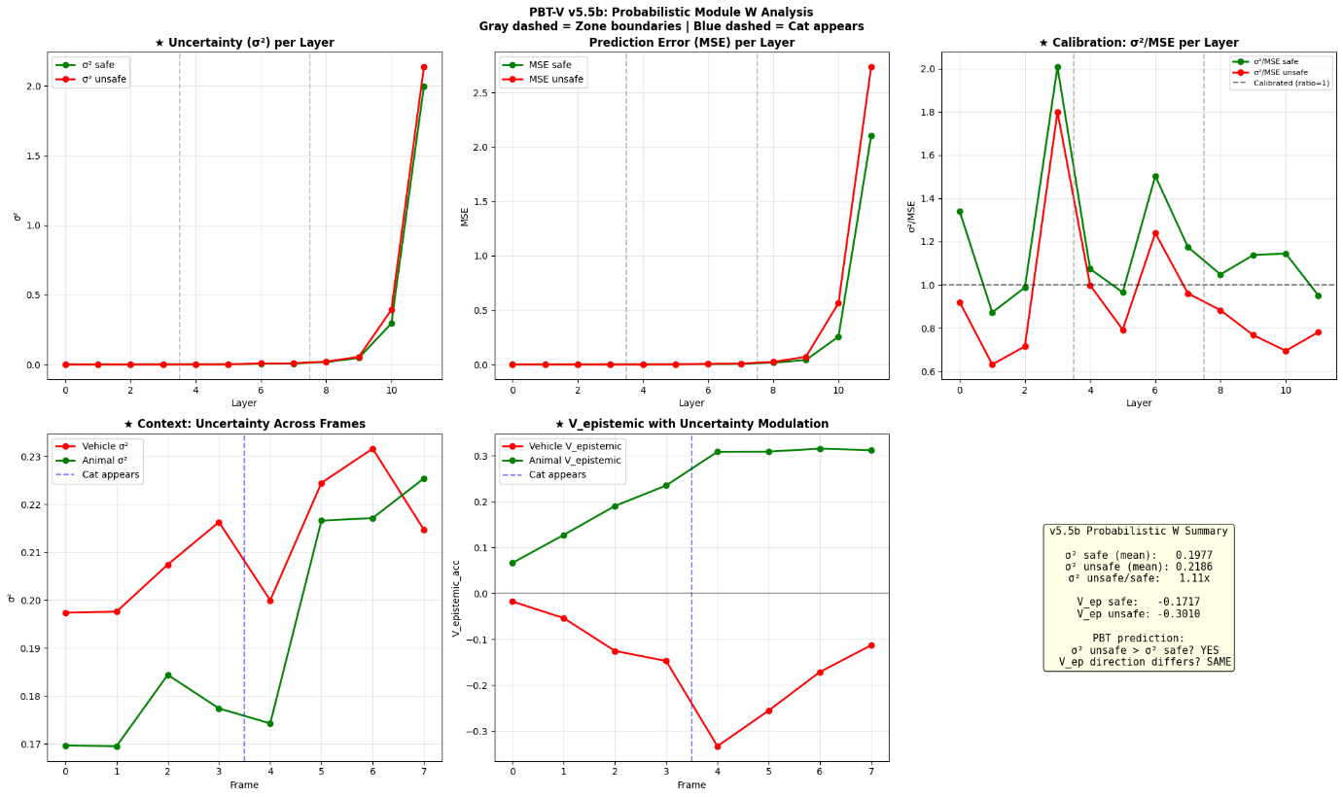
==========================================================================================
v5.5b Analysis Complete!
==========================================================================================

